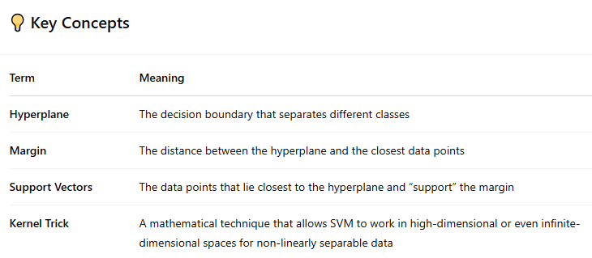

Kernels are **not chosen automatically** by default — you (as the data scientist or developer) usually need to choose the kernel yourself when setting up your SVM.

**Main Hyperparameters in SVM**

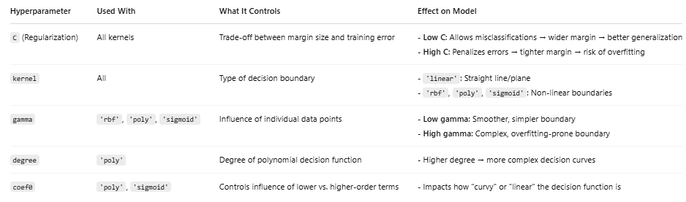

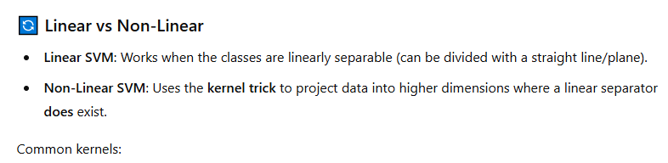

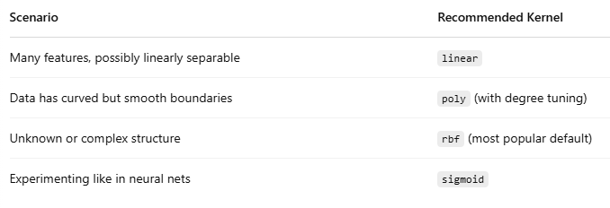

You can automate the selection process using **GridSearchCV** in scikit-learn to find the best kernel and hyperparameters.

